City of Sparta Water Quality Report
WSID#GA1410001

Water Conservation Tips
Did you know that the average U.S. household uses approximately 400 gallons of water per day or 100 gallons per person per day? Luckily, there are many low-cost and no-cost ways to conserve water. Small changes can make a big difference - try one today and soon it will become second nature.
Take short showers - a 5-minute shower uses 4 to 5 gallons of water compared to up to 50 gallons for a bath.
Shut off water while brushing your teeth, washing your hair and shaving and save up to 500 gallons a month.
Use a water-efficient showerhead. They're inexpensive, easy to install, and can save you up to 750 gallons a month.
Run your clothes washer and dishwasher only when they are full. You can save up to 1,000 gallons a month.
Water plants only when necessary.
Fix leaky toilets and faucets. Faucet washers are inexpensive and take only a few minutes to replace. To check your toilet for a leak, place a few drops of food coloring in the tank and wait. If it seeps into the toilet bowl without flushing, you have a leak. Fixing it or replacing it with a new, more efficient model can save up to 1,000 gallons a month.
Adjust sprinklers so only your lawn is watered. Apply water only as fast as the soil can absorb it and during the cooler parts of the day to reduce evaporation.
Teach your kids about water conservation to ensure a future generation that uses water wisely.
Make it a family effort to reduce next month's water bill!
Visit www.epa.gov/watersense for more information.

Source Water Protection Tips
Protection of drinking water is everyone's responsibility. You can help protect your community's drinking water source in several ways:
Eliminate excess use of lawn and garden fertilizers and pesticides - they contain hazardous
chemicals that can reach your drinking water source.
Pick up after your pets.
If you have your own septic system, properly maintain your system to reduce leaching to water sources or consider connecting to a public water system.
Dispose of chemicals properly; take used motor oil to a recycling center.
Volunteer in your community. Find a watershed or wellhead protection organization in your community and volunteer to help. If there are no active groups, consider starting one. Use EPA's Adopt Your Watershed to locate groups in your community or visit the Watershed Information Network's How to Start a Watershed Team.
Organize a storm drain stenciling project with your local government or water supplier. Stencil a message next to the street drain reminding people "Dump No Waste - Drains to River" or "Protect Your Water." Produce and distribute a flyer for households to remind residents that storm drains dump directly into your local water body.

Additional Information for Nitrate
Nitrate in drinking water at levels above 10 ppm is a health risk for infants of less than six months of age. High nitrate levels in drinking water can cause blue baby syndrome. Nitrate levels may rise quickly for short periods of time because of rainfall or agricultural activity. If you care for an infant, you should ask for advice from your health care provider.

Water Quality Data Table
To ensure that tap water is safe to drink, EPA prescribes regulations which limit the amount of contaminants in water provided by public water systems. The table below lists all the drinking water contaminants that we detected during the calendar year of this report. Although many more contaminants were tested, only those substances listed below were found in your water. All sources of drinking water contain some naturally occurring contaminants. At low levels, these substances are generally not harmful in our drinking water. Removing all contaminants would be extremely expensive, and in most cases, would not provide increased protection of public health. A few naturally occurring minerals may improve the taste of drinking water and have nutritional value at low levels. Unless otherwise noted, the data presented in this table is from testing done in the calendar year of the report. The EPA or the State requires us to monitor certain contaminants less than once per year because the concentration of these contaminants doesn’t vary significantly from year to year, or the system is not considered vulnerable to this type of contamination. As such, some of our data, though representative, may be more than one year old. In this table you will find terms and abbreviations that might not be familiar to you. To help you better understand these terms, we have provided the definitions below the table.

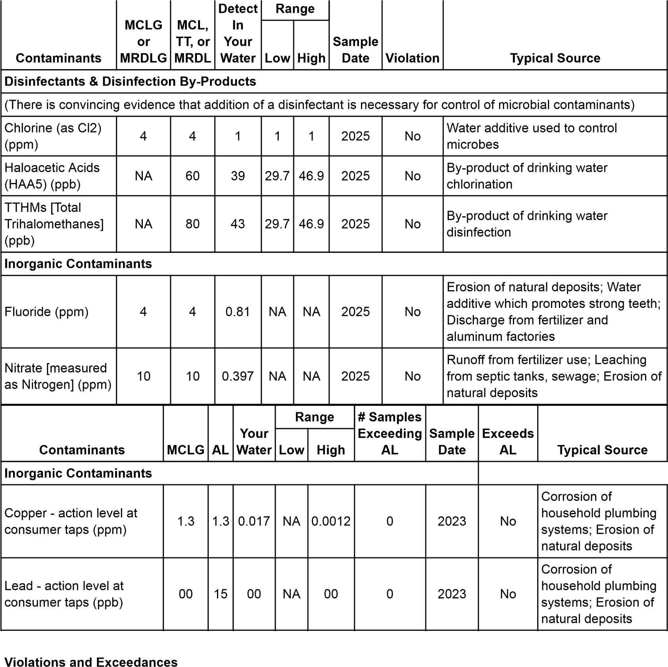

To access all individual Lead Tap Sample results for CITY OF SPARTA, contact: CITY HALL at (706)444-5753

Additional Information for Lead
Lead can cause serious health problems, especially for pregnant women and young children. Lead in drinking water is primarily from materials and components associated with service lines and home plumbing. SPARTA is responsible for providing high quality drinking water and removing lead pipes but cannot control the variety of materials used in plumbing components in your home. You share the responsibility for protecting yourself and your family from the lead in your home plumbing. You can take responsibility by identifying and removing lead materials within your home plumbing and taking steps to reduce your family’s risk. Before drinking tap water, flush your pipes for several minutes by running your tap, taking a shower, doing laundry or a load of dishes. You can also use a filter certified by an American National Standards Institute accredited certifier to reduce lead in drinking water. If you are concerned about lead in your water and wish to have your water tested, contact CITY HALL (Public Water system Id: GA1410001) by calling 706-444-5753 or emailing spartamayor@cityofsparta.org. Information on lead in drinking water, testing methods, and steps you can take to minimize exposure is available at http://www.epa.gov/safewater/lead.
Service Line Inventory (SLI)
The Service Line Inventory (SLI) is a requirement under the Lead and Copper Rule Revisions (LCRR) to help water systems identify and replace lead service lines. It mandates that all public water systems develop and maintain an inventory of service line materials to assess the presence of lead and protect public health. The inventory will support proactive lead reduction efforts and ensure compliance with regulatory requirements to minimize lead exposure in drinking water. To access the SLI for CITY OF SPARTA (Water System Name):
Service line inventory can be accessed through the Service Line Inventory Public Transparency Dashboard at https://ga-epd.120water-ptd.com/ or by request at city hall.

Unit Description
Term | Definition
ppm | ppm: parts per million, or milligrams per liter (mg/L)
ppb | ppb: parts per billion, or micrograms per liter (µg/L)
NA | NA: not applicable
ND | ND: Not detected
NR | NR: Monitoring not required but recommended.
Important Drinking Water Definitions
Term | Definition
MCLG | MCLG: Maximum Contaminant Level Goal: The level of a contaminant in drinking water below which there is no known or expected risk to health. MCLGs allow for a margin of safety.
MCL | MCL: Maximum Contaminant Level: The highest level of a contaminant that is allowed in drinking water. MCLs are set as close to the MCLGs as feasible using the best available treatment technology.
TT | TT: Treatment Technique: A required process intended to reduce the level of contaminants in drinking water.
AL | AL: Action Level: The concentration of a contaminant which, if exceeded, triggers treatment or other requirements which a water system must follow.
Variances and  Exemptions | Variances and Exemptions: State or EPA permission not to meet an MCL or a treatment technique under certain conditions.
MRDLG | MRDLG: Maximum residual disinfection level goal. The level of a drinking water disinfectant below which there is no known or expected risk to health. MRDLGs do not reflect the benefits of the use of disinfectants to control microbial contaminants.
MRDL | MRDL: Maximum residual disinfectant level. The highest level of disinfectant is allowed in drinking water. There is convincing evidence that addition of a disinfectant is necessary for control of microbial contaminants.
MNR | MNR: Monitored Not Regulated
MPL | MPL: State Assigned Maximum Permissible Level
90th Percentile | Compliance with the lead and copper action levels is based on the 90th percentile lead and copper levels. This means that the concentration of lead and copper must be less than or equal to the action level in at least 90% of the samples collected.
For more information please contact:
Contact Name: HAYWOOD, ALLEN
Address: 12912 BROAD STREET, PO BOX H
SPARTA, GA 31087
Phone: 706-444-5753


